Architecture and Design Collection, Rights and Reproductions 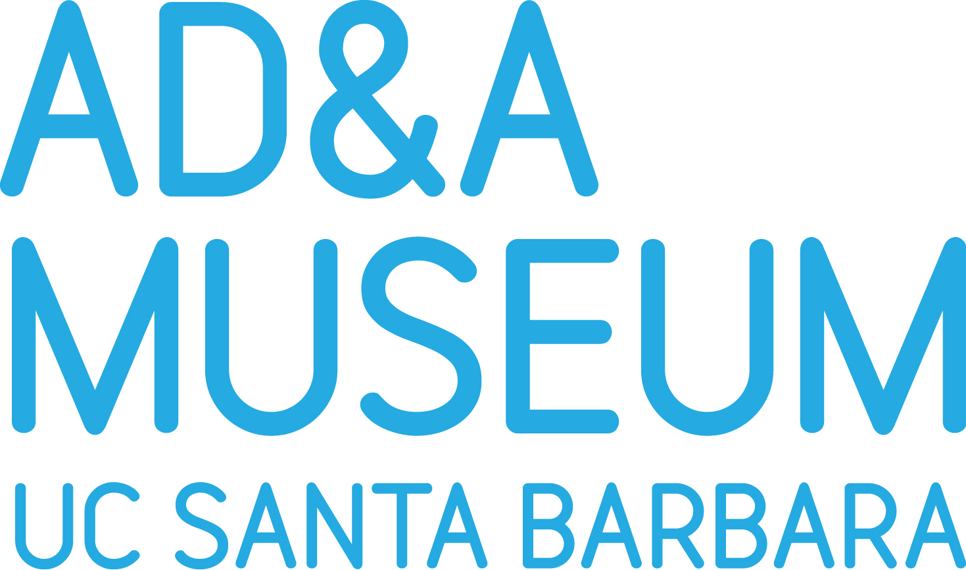
All fees are per image and include a high resolution, publication-quality digital image file. For Website and other online applications, digital files are optimized for screen viewing at 72 ppi. It is the responsibility of the user to obtain rights from the copyright holder. Digital files will be delivered electronically. Images may be burned to DVDs for a charge of $10 per disk. All fees are subject to change.
REPRODUCTION FEES
 | New photography | Existing digital image
Digital file  Original 15 ½ x 11 ½ in. or smaller | $35 | $25
Digital file  Original larger than above* | $65 | $35
Digital file, black-and-white  for architectural drawings only* | $65 | $35
Models, furniture and other 3-dimensional work, quoted per request | Quoted per object | $35
UC Students and Faculty  (with ID) | Contact for rates | Contact for rates
*Note: a handling surcharge may need to be added for fragile, large drawings
SERVICE FEES
 | Scholar, under 5,000 copies  (includes theses and dissertations) | Non-Profit under 5,000 copies | For profit, educational and non-profit 5,000 or more copies | Commercial
BOOKS (incl. catalogues, CD-ROMS, DVDs. CDs) | waived | $25 | $75 | $100
Re-use fee | waived | waived | waived | $50

 | Scholar, under 5,000 copies | Non-Profit under 5,000 copies | For Profit Educational and Non-Profit 5,000 or more copies
SCHOLARLY JOURNAL | waived | $50 | $75

MAGAZINES | Circulation 250,000 or less | Circulation over 250,000
inside | $100 | $200
Cover | $200 | $500

 | Circulation 250,000 or less | Circulation over 250,000
NEWSPAPERS | $75 | $100

 | Scholar | Non-profit | For profit educational
WEBSITE/BLOG/DIGITAL APPLICATION | $15 | $50 | $100
Requests for commercial and non-editorial use of images are individually considered.
Architecture and Design Collection
Art, Design & Architecture Museum
Room 1626, Art Building
University of California, Santa Barbara
Santa Barbara, CA 93106-7130
adc@museum.ucsb.edu

AD&AM 2011-10-25, rev 2012-04-18

