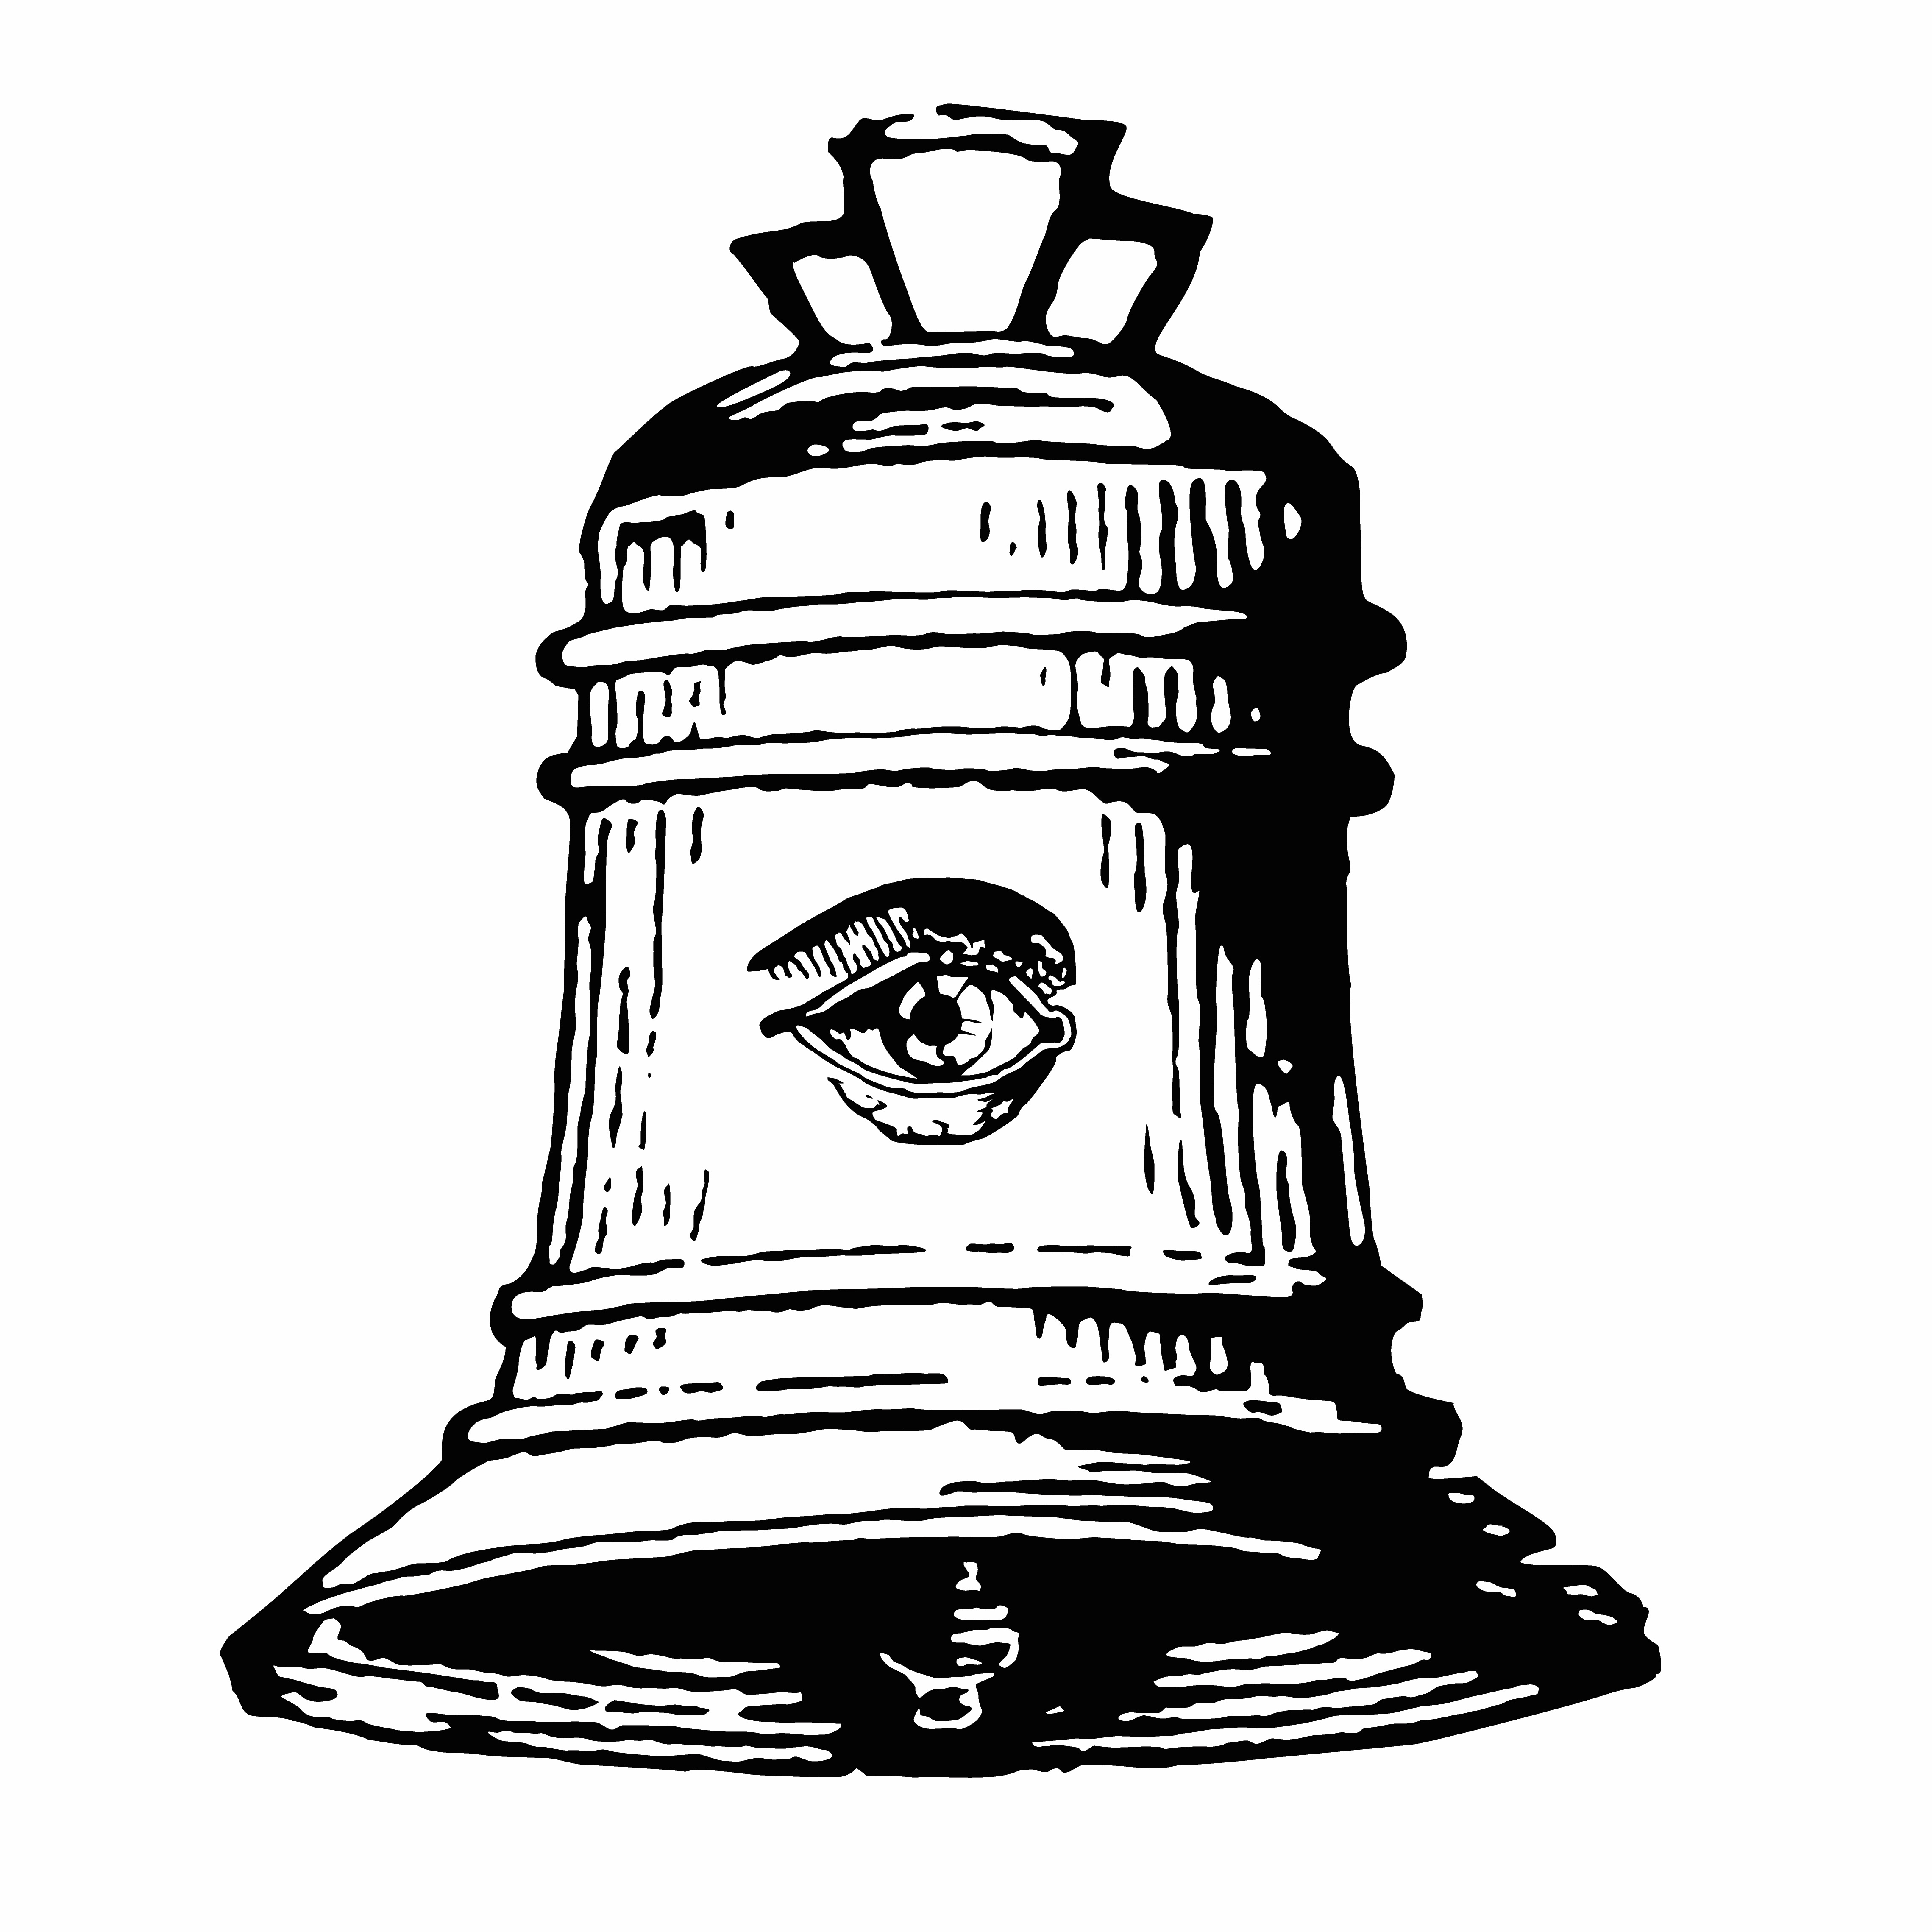

THE PANAMERICAN ADDRESS OF THE PEOPLE OF
SANTA BARBARA

We, the people and residents of the City of Santa Barbara, on this day, Saturday, November 4, 2017, at the Art, Design and Architecture Museum, UC Santa Barbara declare the following:

We want to continue to embrace the beauty and pace of our town,

We value our intimate community while respecting our international draw,

We identify that the housing and transportation is incapable of supporting the breadth and diversity of our vibrant culture and its inhabitants,

We would like to see the city provide the resources for more mixed used space and communal forms of transportation,

Whereas the city’s visual backdrop is beautiful,

Whereas the ratio of the city’s size to its cultural resources is remarkable,

Whereas the debilitating socioeconomic stratification and fragmentation is detrimental to the livelihood of the city,

Whereas the city has an entrenched cultural climate,

Whereas we scapegoat the homeless,

Whereas this is a site of festering potential energy,

Whereas it is beautiful here,

Whereas you need to pay to play,

Whereas capital drives culture,

Whereas museums and the arts are catalysts of civic engagement,

We will create more grassroots collective action to produce alternative spaces,

We will produce startling ephemeral gestures as public art,

We, as artists, will intervene in para-professional roles to advance social change,

We will not wait for permission,

We will be the watchdogs of the city’s progress,

We will mobilize ourselves as an arts advocacy group from this moment on out,

We are not going away,

We will be the change and fight artistic censorship even if we will all go to jail,

We will build a more fully integrated city with no invisible citizens, and will generate the resources to allow the citizens to shine with the same beauty that this land has bestowed on us.

Signed,

Gerardo Ayala

Madeleine Ignon

Yara El-Sherbini

Joe Beraldo

Emilio Abarca

Maria-Lisa Flemington

Barbara Parmet

Sara Reisman

Lisbeth Springer

Zachary Rosen

Jamie Bishop

Natalie Sanderson

Sophia Sobko

Andi Garcia YQue!

Maiza Hixson

Elyse A. Gonzales

Steve Thompson

Tom Pazderka

Casey Caldwell

Pablo Helguera (Secretary)

